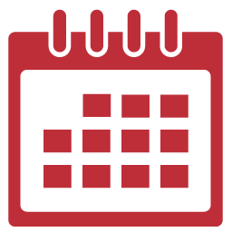
Regular Visits with Healthcare Providers
Visit every 6 months if all is well
Visit every three months if BP is not controlled
4-6 weeks after a change to medication
Annual Physical
My next appointment is
_________________________
My Annual Physical is scheduled for
_________________________
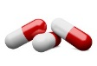
Take Medications
It is important that you take your prescriptions as prescribed.
Please let your healthcare provider know if there is some reason you cannot take them (cost, side effects, trouble taking them, etc)
My current Medications and dosages
____________________________________________________________________________________________________________________________________
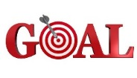
Set Goals
In order to achieve success in controlling your BP set some goals and follow up with your healthcare provider for help meeting them.
Examples:
I will exercise 2 times a week
I will stop smoking
I will follow the DASH diet for 1 week
I will take my medication everyday
My Goals Are:
_________________________________
_________________________________
_________________________________
_________________________________
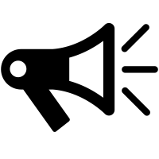
Keep your Primary Care Provider Informed
Please let us know if you see specialists, have tests, or lab work done at other facilities. Ask those other facilities to forward your results or office notes to your primary care provider.
Fax to: (919)875-1051
Raleigh Family Practice
Help to Manage Your Hypertension

Why is it important for my BP to be controlled?
Uncontrolled BP can lead to many more serious issues such as heart disease, stroke and heart attack. Keeping your BP in control is a step in the right direction to improve your risk of such future problems.
Know the numbers:
Controlled/Normal BP: < 120/80
Great Job keep up the good work!
Moderate BP: 120/80-139/89
May require some lifestyle changes with diet, exercise, etc.
High BP: 140/90 Make sure you are taking medications as prescribed and check with your healthcare provider about possibly making medication changes.

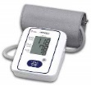
Monitor Blood Pressure
Purchase a BP Monitor.
Record your Blood pressure and report it to your healthcare provider.
Fax: 919-875-1051
Email: kfisher@rfppa.com
Bring your monitor to a visit so that you can compare with our instruments and verify accuracy.
I should check my BP: ________________________________
And report it to my healthcare provider ________________________________
We will provide a Blood Pressure log to you, there are also several apps for smart phones that log BP.
My Target BP is ___________________
If my BP is greater than _____________
I should: _________________________
If my BP is less than ________________
I should: _______________________

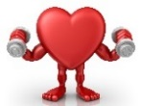
Exercise Regularly/
Maintain a Healthy Weight
Talk to my healthcare provider about how often and how strenuous my exercise should be.
My Ideal weight is __________________
I should exercise ___________________
Exercises I can do __________________
____________________________________________________________
Follow a DASH Diet (Dietary Approach to Stop Hypertension)
This plan is proven to help reduce Blood Pressure and help with weight loss through a heart healthy diet and reducing sodium (salt) in your diet.
We are happy provide information on the DASH diet. You can also find information on the National Heart Lung and Blood Institute website at
www.nhlbi.nih.gov

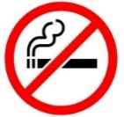
Stop Smoking/
Talk with your healthcare provider about ways to stop smoking
Smoking causes an immediate spike in blood pressure and can raise systolic blood pressure levels by as much as 4 millimeters of mercury (mm Hg). The nicotine in tobacco products spur the nervous system to release chemicals that can constrict blood vessels and contribute to high blood pressure.
Smoking also causes long-term damage to blood vessels, so beyond the hypertension risk, this habit further increases the chance of developing problems like stroke, heart disease, and heart attack. The combination of smoking and hypertension puts you at greater risk of having a heart attack, stroke, or other cardiovascular event compared to non-smokers with hypertension.
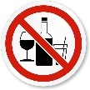
Limit Alcohol Consumption
Limiting alcohol to 2 drinks a day for men and 1 drink a day for women lowers blood pressure

